# **Introduction**

This software is aiming at helping user to analysis performance data of Pentamaster handler by using different charts:

* + Alarm quantity summary during user defined date period with interactive alarm list
  + Top 7 alarm trend over days
  + MUBA trend
  + Alarm distribution in selected day
  + UPH trend by lot
  + Top vision yield trend by lot
  + Test yield trend by lot
  + OEE data base reading
  + Total down time spent on each jam
  + Average down time spent on each jam
  + Export jam information and down time information in CSV format

# **Installation guide**

This software is developed on “.net 4.0” run time environment, so please make sure the “.net 4.0” framework is installed on your machine.

1. For windows XP, please install “wic_x86_enu.exe” first.

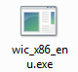

1. Install “Microsoft.NET4.0.exe”.

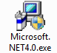

1. Copy program files to one folder

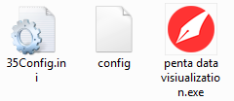

1. Send short cut of “penta data visualization.exe” to desktop

# **Features introduction**

## Jam summary and top 7 jam trend

Process time

Alarm path

Version

Top 7 alarm trend chart in selected period

Previous week

Previous day

Today

Export to CSV

Run calculation

Date picker for end date

Date picker for start date

Alarm names list

Alarm quantity summary chart

Tab pages for different data information

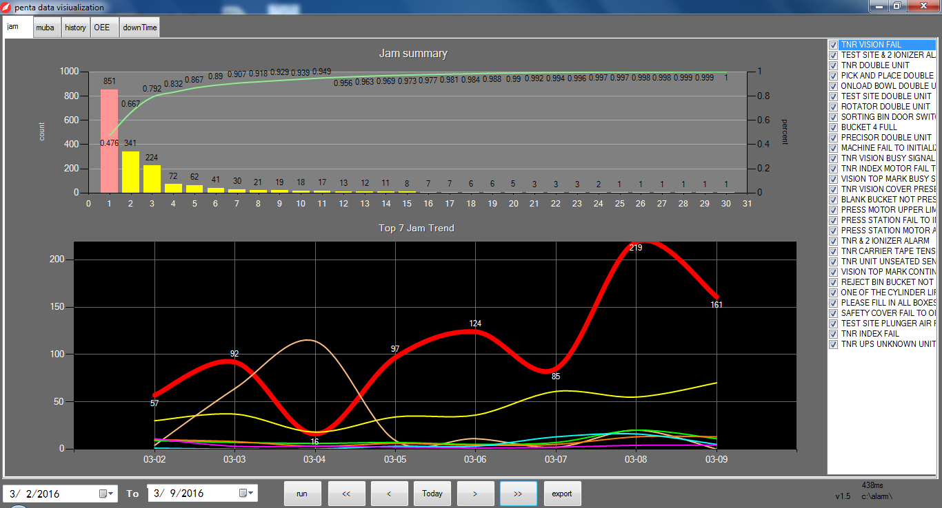

## Tips

* + - Once you launch the software, it will automatically calculate last week’s data
    - Default alarm path is “c:\alarm\”, if the actual path is not the same, please edit “config” file in program folder:

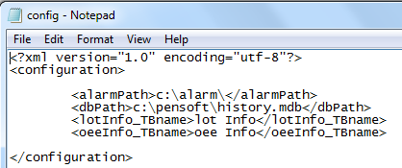

* The alarm list support interactive operation, once one item selected, that item will become red in “jam summary” chart, the if selected item is belong to top 7, the “top 7 jam trend ” chart will highlight that item.
* If one alarm quantity 200 during one day, the background will become darker, and the y-axis maximum value will become to that max value

*\*The checkbox of jam list not function now*

## MUBA and jam distribution

## 

Muba trend

Top 7 Jam distribution

In a day

* + Tips:
    - The MUBA data is a gross value, it calculate by the “machine cycle data” in log file and jam quantity in previous step:



* + - The default maximum value of Y-axis is 3000, if MUBA exceed 3000, the maximum will auto change to the max muba.

## History database reading

## 

Data gird

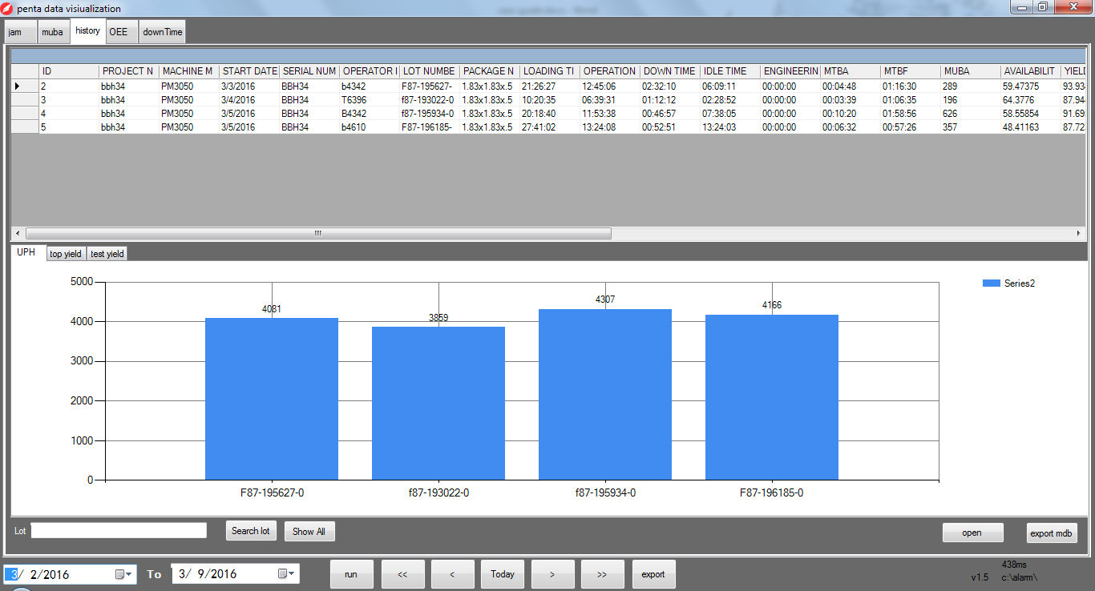

Tab pages for other different data

Export the database to CSV

Manual open a History.mdb file

Manual read data during selected period and draw chart

* + Tips
    - Database file using here is “History.mdb”, and default path is “c:\pensoft\history.mdb”, if actual path is different, please edit the “config” file in program folder.
    - Top yield is gross value, it calculated by : top reject quantity/output quantity*100% of each lot

## OEE database reading

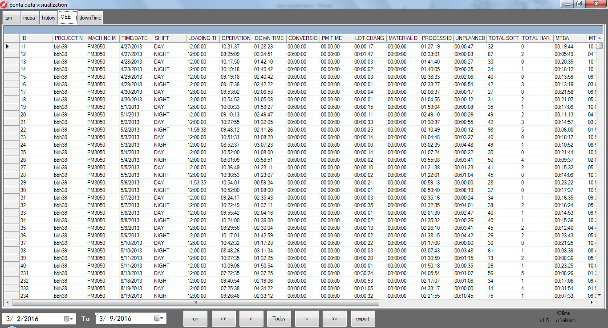

* + Tips
    - Database using here is History.mdb
    - Just for data reading, nothing to do with the data now.

## Down time analysis

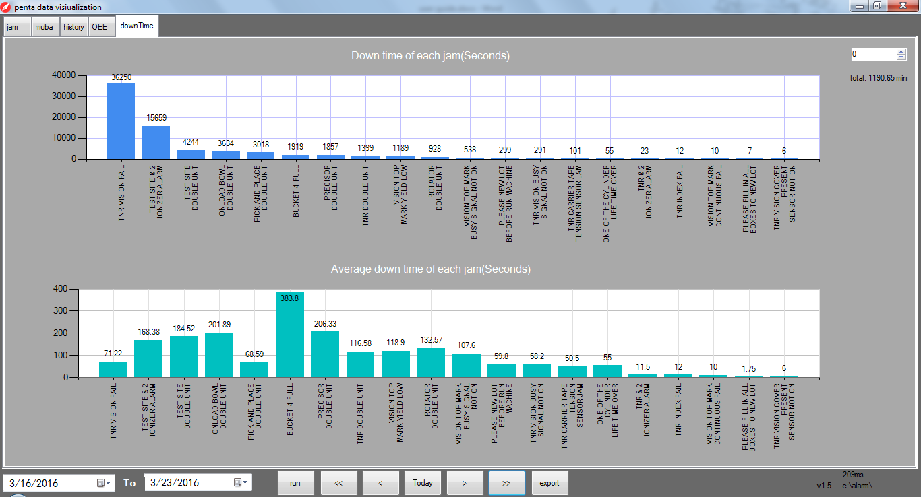

Export data to CSV

Total down time (minutes)

Change chart type

* + Tips
    - Total down time data calculate base on log file:

# **Alarm list edit**

* + - * + You may edit which alarm take in to calculation by edit the “35config.ini” file in program folder

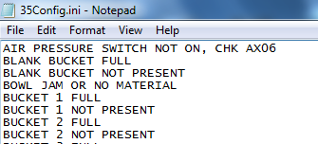

* + - * + For alarm with station No. like “Test site#1 double unit”/ ”test site#2 double unit”, type in “ Test site double unit”, because program already filtered “#?” before calculation.
        + make sure no empty row